https://play.mynaia.org/media/1127/logo-playnaia-fpo-only-2x.png

**Freshman Eligibility Rules**

* 2.3 Overall GPA for recent graduates

Students who **do not** meet the 2.3 minimum GPA requirement upon graduation may still become eligible to compete at an NAIA school by meeting 2 of the following 3 criteria:

* Minimum test score of 18 on the ACT or 970 on the SAT
* Achieve a minimum overall high school GPA of 2.0 (on a 4.0 scale)
* Graduate in the top half (50%) of their high school class

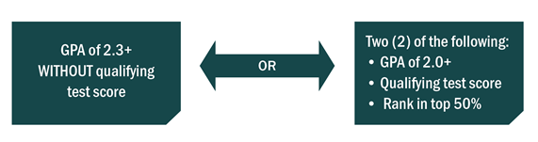

**ACT SAT**

**18 970**